Find open ports on the machine

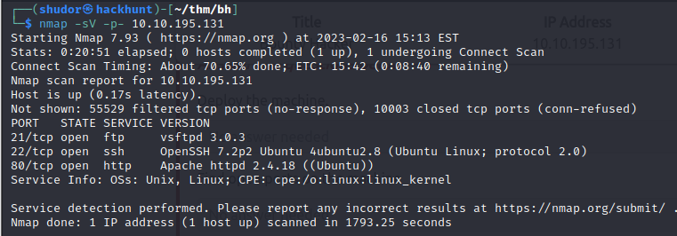

Who wrote the task list?

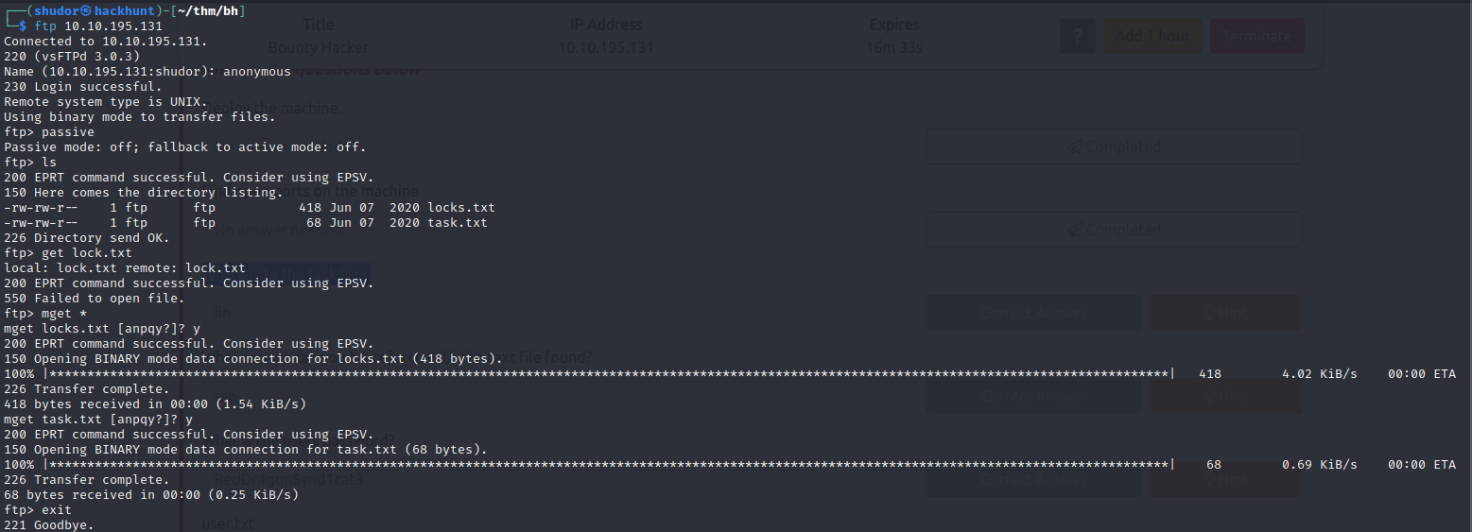

What service can you bruteforce with the text file found?

From nmap scan we can find the service which running with the port which is running

What is the user’s password?

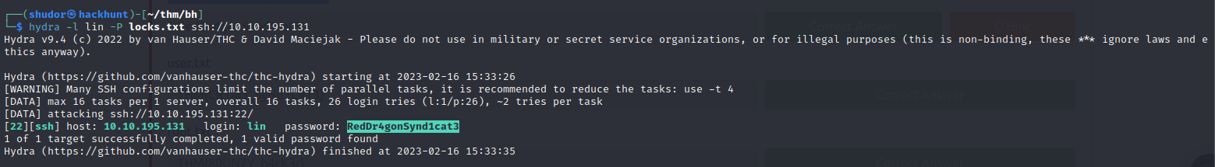

user.txt

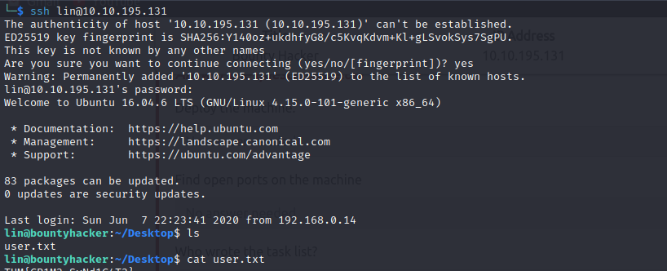

root.txt

